HOMEWORK QUESTION 1 (5 pts)
- Plant molecular biology

- GenomicFeatures: https://www.bioconductor.org/packages/release/bioc/html/GenomicFeatures.html

GenomicAlignments:
https://www.bioconductor.org/packages/release/bioc/html/GenomicAlignments.html

pwalign:
https://www.bioconductor.org/packages/release/bioc/html/pwalign.html

- pwalign appears to be the easiest to learn because it has one R script

HOMEWORK QUESTION 2 (5 pts)
- It pulls up Keyboard Shortcut Quick Reference page
- It will pull up your previous command line
- It clears the console
- Esc or ctrl + c

HOMEWORK QUESTION 3 (5 pts)
- class(users) – character
class(logins) – numeric

- class(super_vector- character
R vectors must contain the same data types but because characters cannot be converted to numerical values easily numbers are automatically converted to characters

- > super_vector_num <- as.numeric(super_vector)
Warning message:
NAs introduced by coercion
> print(super_vector_num)
[1] NA NA NA 12 5 34
The output [1] NA NA NA 12 5 34 shows that "alvin", "viet", and "leila" were replaced by NA because they cannot be converted into numbers, while the original numeric strings were successfully converted back to numbers.

HOMEWORK QUESTION 4 (5 pts)
# Heather's code:
languages <- c("English", "Spanish", "Japanese", "French")
greetings <- c("hello", "hola", "ohio", "bonjour")
partings <- c("bye", "adios", "mata", "salut")
dictionary <- data.frame(languages, greetings, partings)
dim(dictionary)
dictionary

HOMEWORK QUESTION 5 (5 pts)
To sync up my dataset to my current directory I navigate to files, go to the folder I want to work in and go to set as working directory.

Yes is can use both read.table() and read.csv() to import datasets
Yes I can save it as an object
lifeExp <- read.table("life-expectancy_1900-2023_CountriesOnly.csv", sep = ",", header = TRUE)
# EDA
dim(lifeExp)
str(lifeExp)
class(lifeExp)
summary(lifeExp)

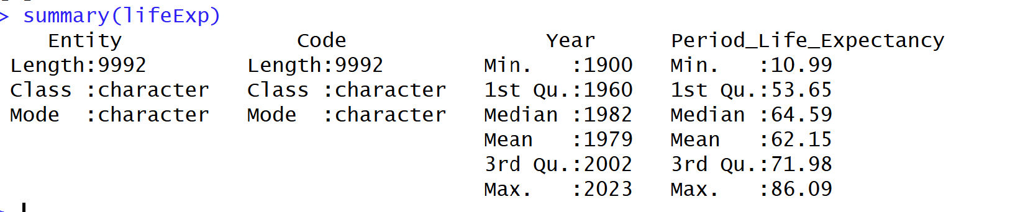

lifeExp$Entity <- as.factor(lifeExp$Entity)
lifeExp$Code <- as.factor(lifeExp$Code)

